Noakhali Science and Technology University



Assignment Title: Troubleshooting
Course Title: Information Technology Fundamentals
Course Code: ICE-1101

Submitted by:  Name: Maimoona Hoque Jerin  ID: BBH-2111032F  Year-1; Term: 1  Session :2020-2021  Department of Communication Engineering  NSTU | Submitted To:  K.M .Aslam Uddin  Assistant Professor  Department of Communication Engineering  NSTU
Date of Submission : 22-09-2022
Problem 1 (Title): Frozen Start Menu Task Bar
- Click Windows logo menu + r
- Then type taskmgr
- Then click Windows Explorer
- Then click on End to close it
Screenshots:

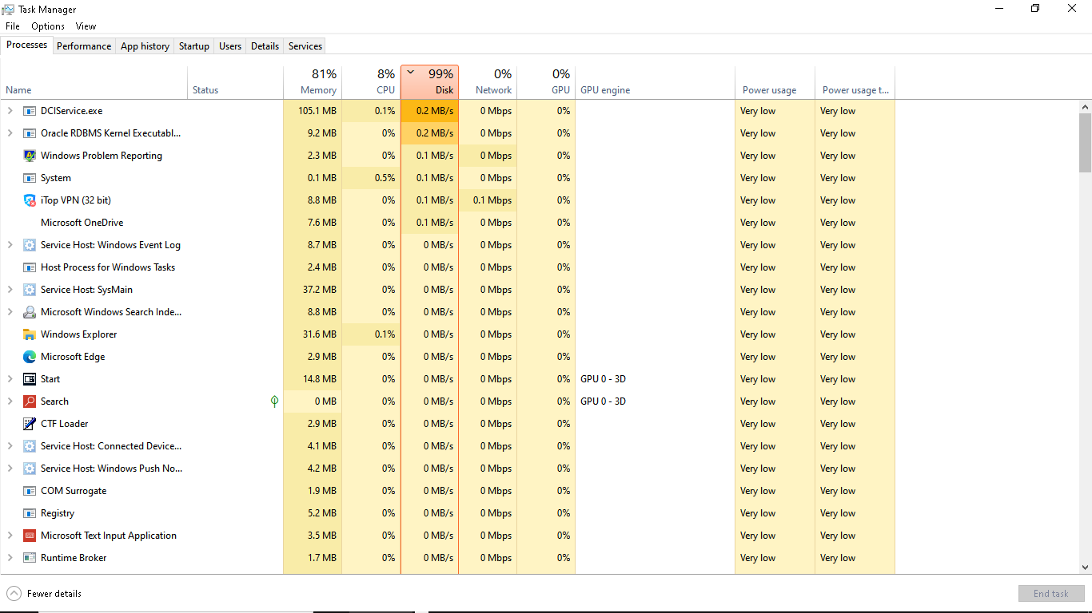

Link : https://chris’ Tutorials. Com / frozen start menu task bar

Problem 2 Title : How to speed up my laptop :
Step 1 :
- In start menu search power option
- Then click on it
- Get control panel
- Change setting for plan Balanced

Screenshots:

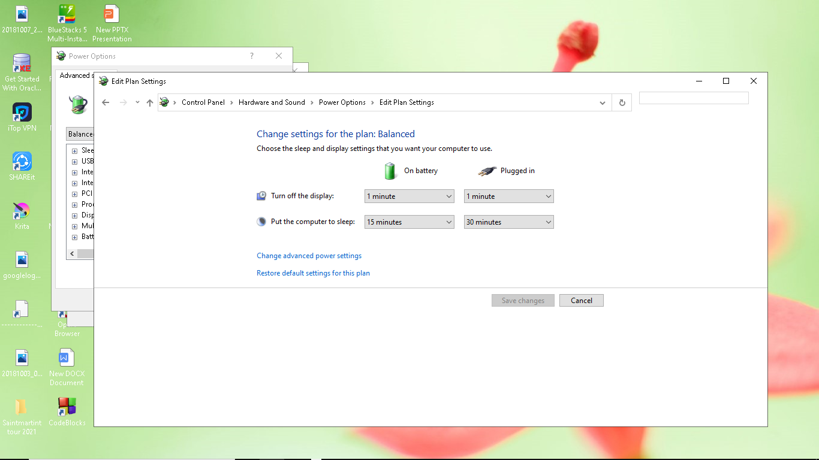

Step 2 :

- Press Windows +r
- Then Type taskmgr
- Then click Startup and I see what program is enable and what program is disable
Screenshots :
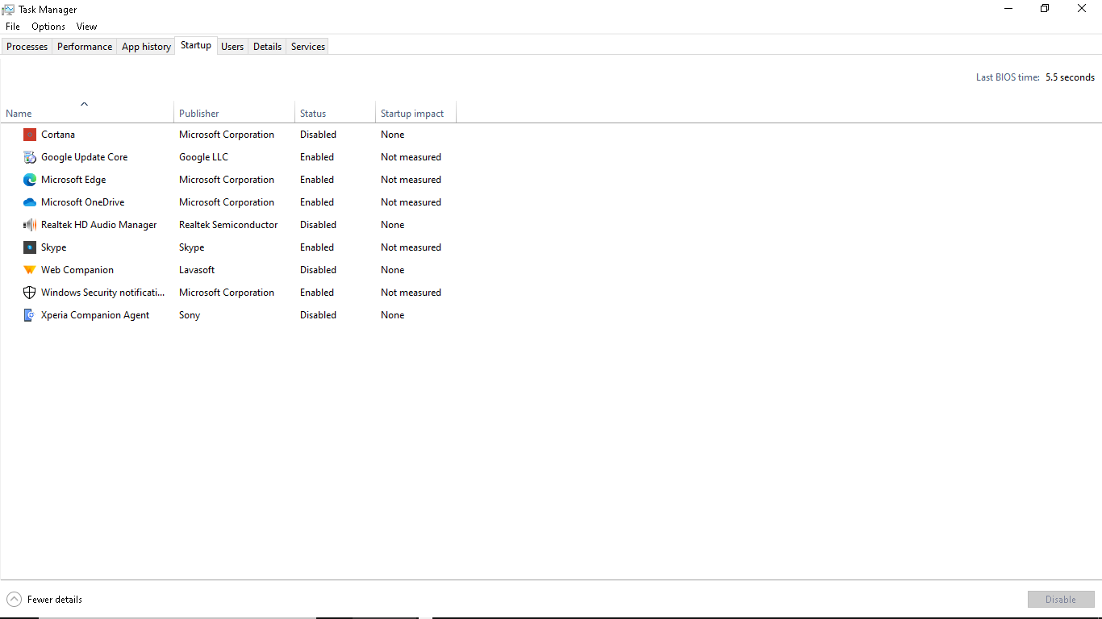
Step 3
Defragment and Optimize Device:
- Go to the start menu and search defragment and optimize device
- Click on thi
- Then select C and click on Optimize
- Now I can see system drive is optimizing
- Screenshots:
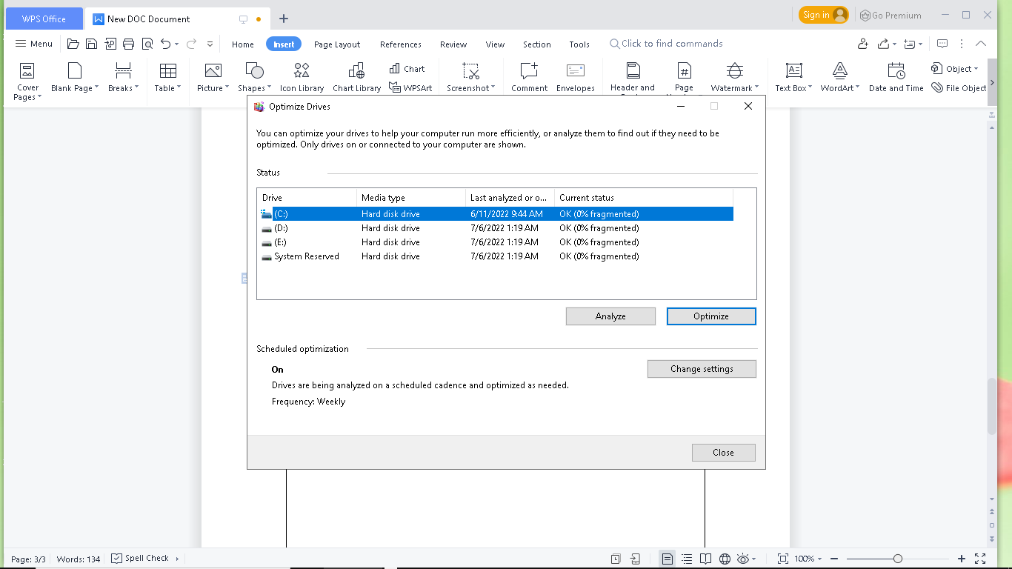
Step 4:
Delete Unnecessary Temporary Files
- Windows logo +r=%temp% and click on this
Screenshots :
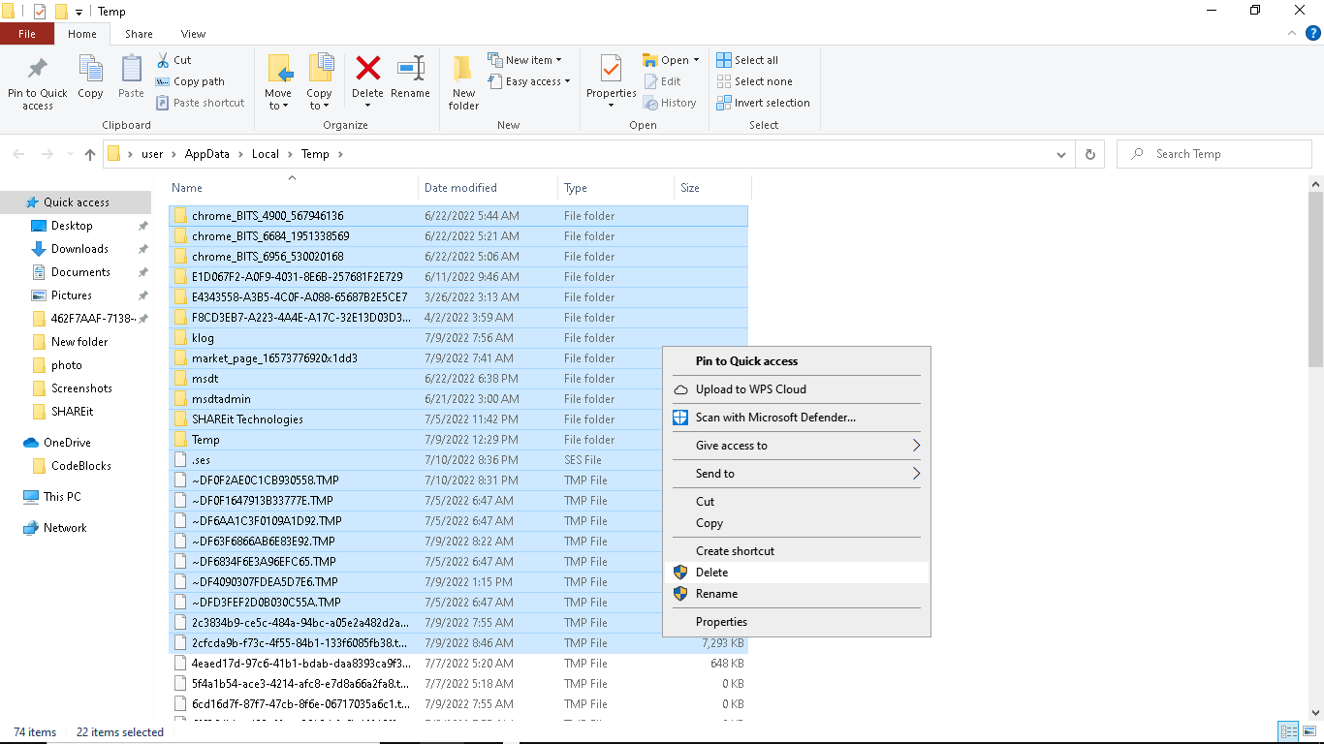

Step 5 :
Clean up Memory
- Go to File Explorer
- Right Click on system drive
- Screenshots:
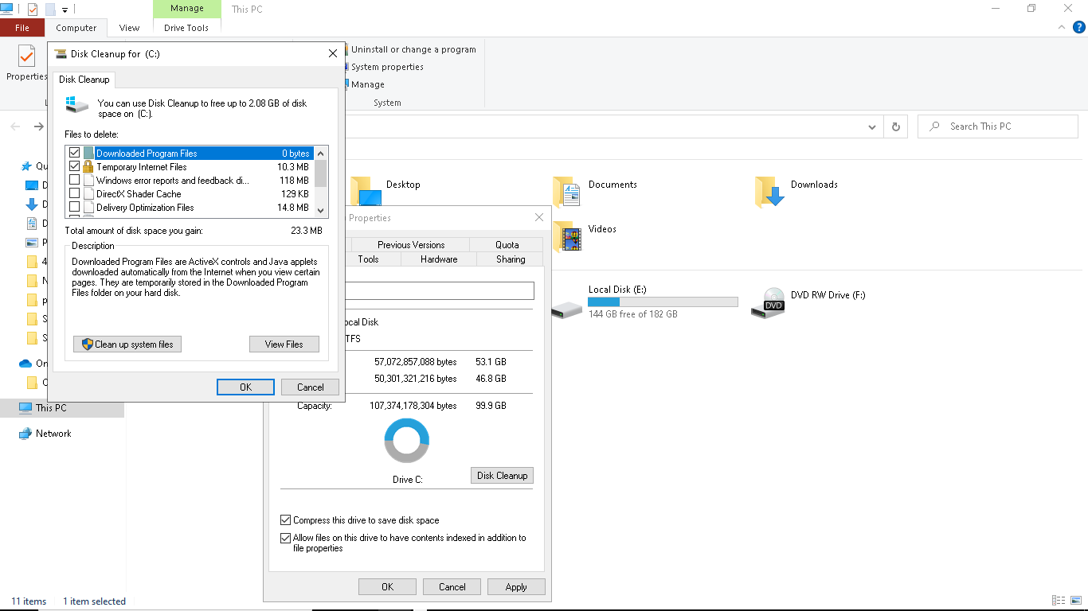

Link :https://youtube/oaVeT9Ayfc4

Problem 4

- Write click on windows Disk Management
- Write click on drive and Shrink Volume [100 GB =(100*1024 MB)]
- Write click and new simple volume
- Next Next Finish

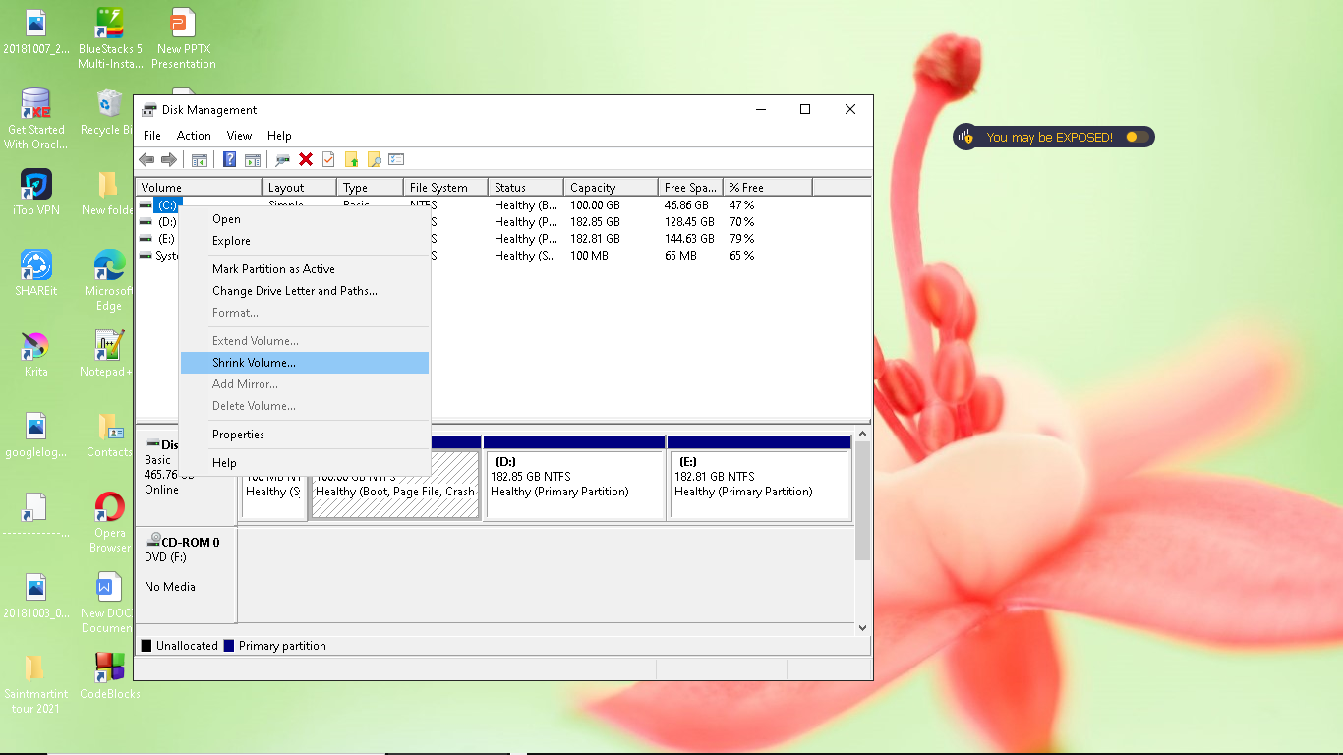

Problem 5
How to Enable or Disable USB Port of Laptop
Disable USB Port
Step 1: windows +r
Step 2 : run + regedit
Step 3 : Services and Application go to HKEY _LOCAL _MACHINE
Step 4: HKEY_LOCAL_MACHINE go to SYSTEM
Step 5: SYSTEM go to Current control set
Step 6: Current control set to Service
Step 7 : Service to USBTOR
Step 8: USBSTOR to START
Step 9: Start to Value data :4

Screenshots :

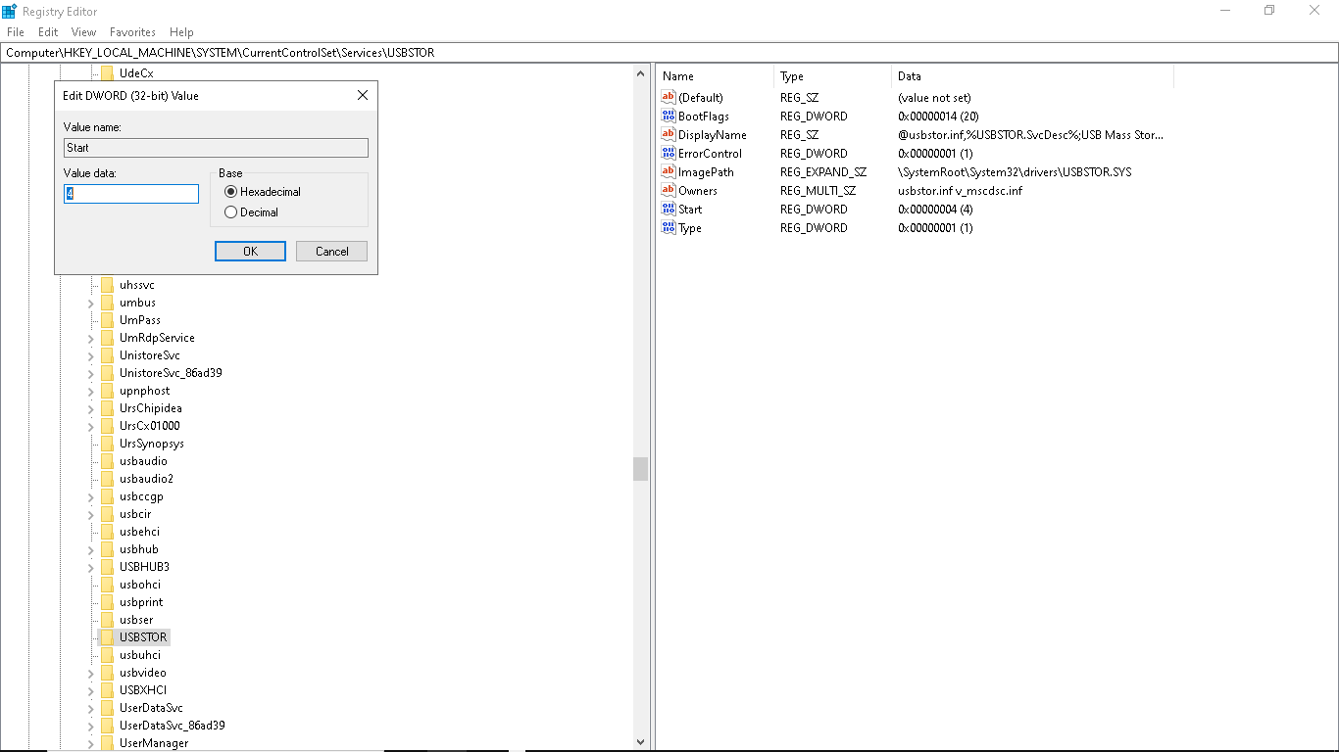

Enable USB Port

Step 1: windows +r =run
Step 2 :run to regedit
Step3:Services and Applications to HKEY _LOCAL_MACHINE
Step 4 :HKEY_LOCAL_MACHINE to SYSTEM
Step 5:SYSTEM to Current Control Set
Step 6 : Current Control Set to Service
Step 7 : Services to USBSTOR
Step 8 : USBSTOR to Start
Step9: Start to Value data :3

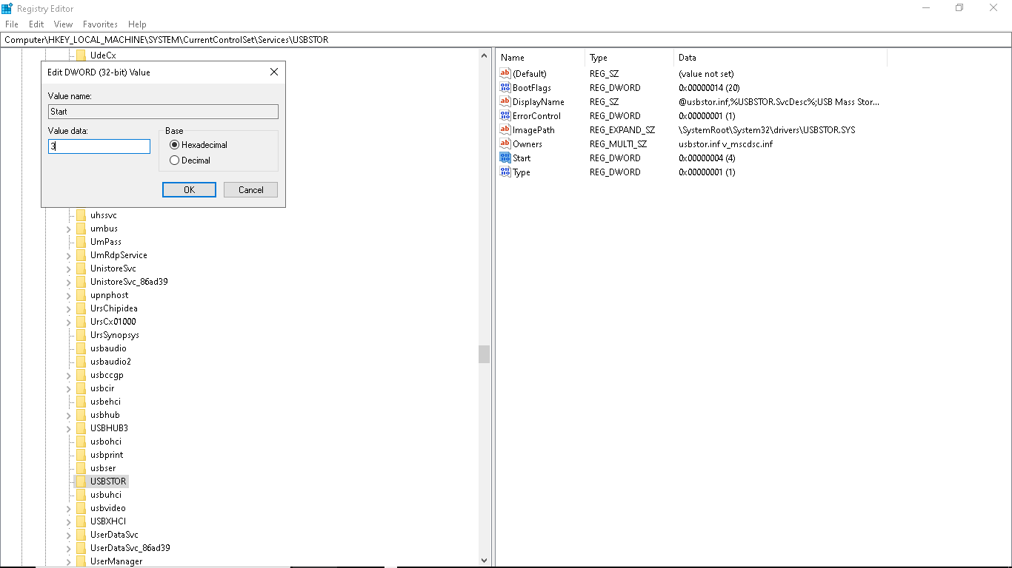

Problem 6
Set Password At Windows

Step 1 : Settings

Step 2: Settings to Account

Step 3 :Accounts to Sign In Options

Step 4 :Sign in options to Password

Step5 : password to Select When PC wakes up from sleep

Step 6: Need change password

Screenshots:

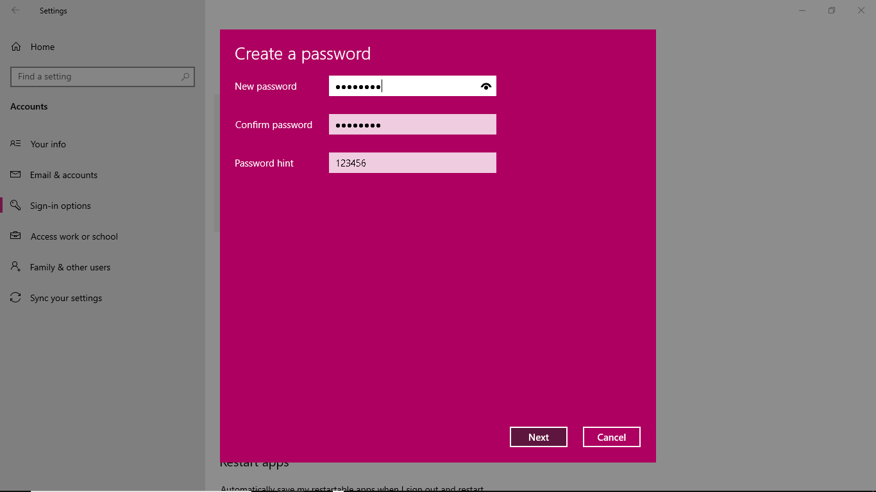

Delete Password at windows

Step 1 : setting

Step2:setting to account

Step3:accounts to sign in options

Step4: sign in options to change in password

Step 5:in password hint type no password
Screenshots: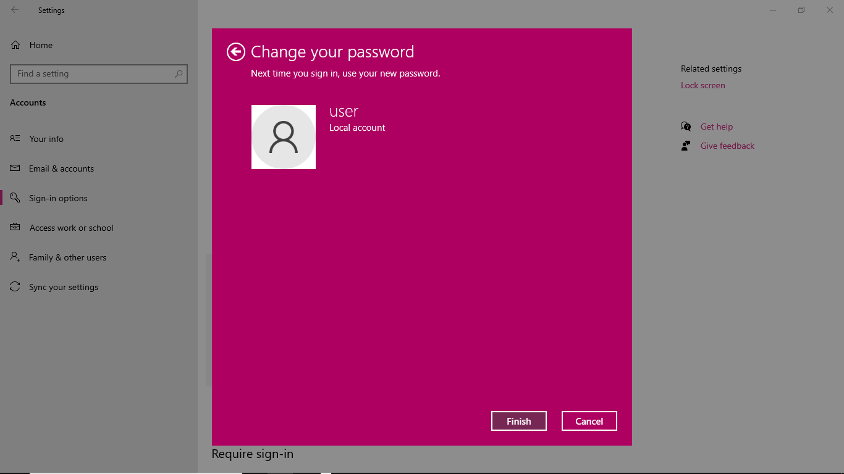Problem 7

Update Device Driver Software

Step 1: search the taskmanager and search Device Manager

Step2 :Click on update device manager

Step 3 :click on update device software for each driver

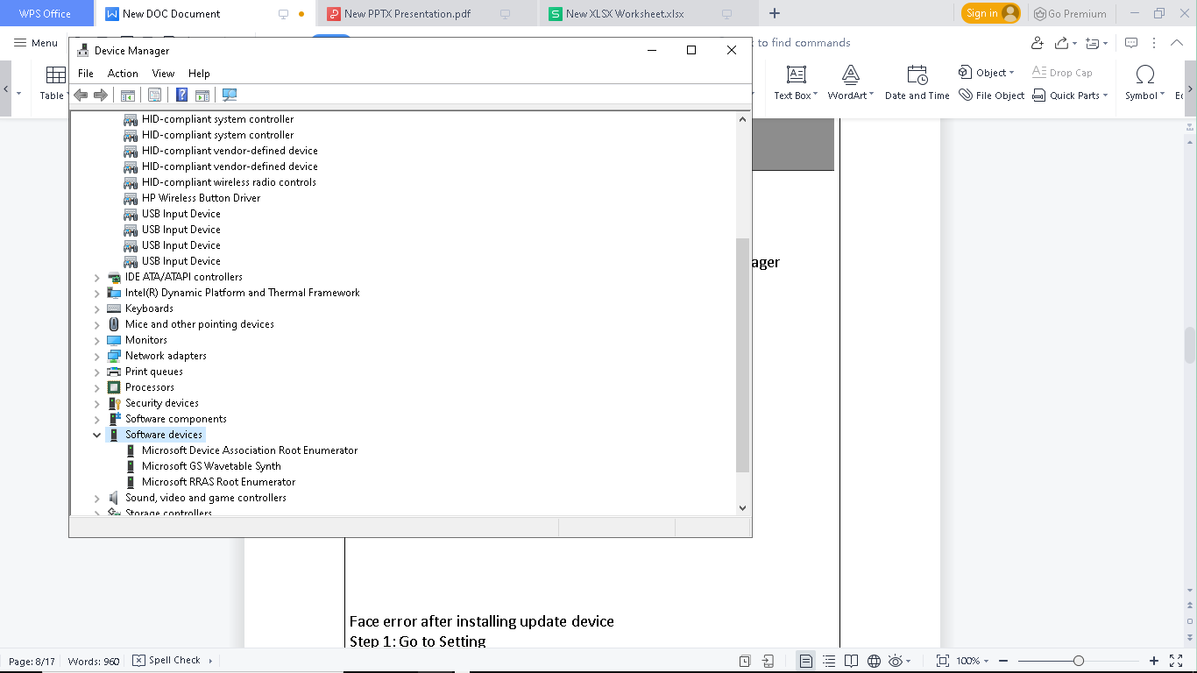

Face error after installing update device
Step 1: Go to Setting
Step2:Updates Security click on windows update

Step3:click on uninstall update
Screenshots:

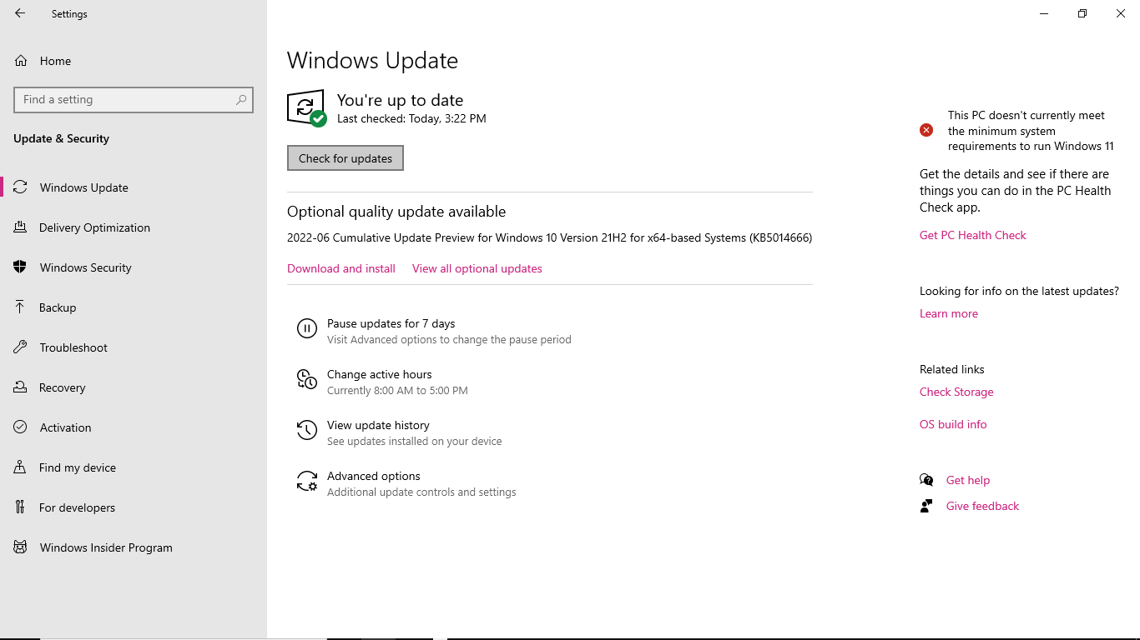

Problem 8

Desktop PC Restarting
Step1: go to Control Panel system properties
Step 2:click on the advanced tab under the and recovery option
Step3: click on the settings uncheck the automitically restart option

Screenshots:

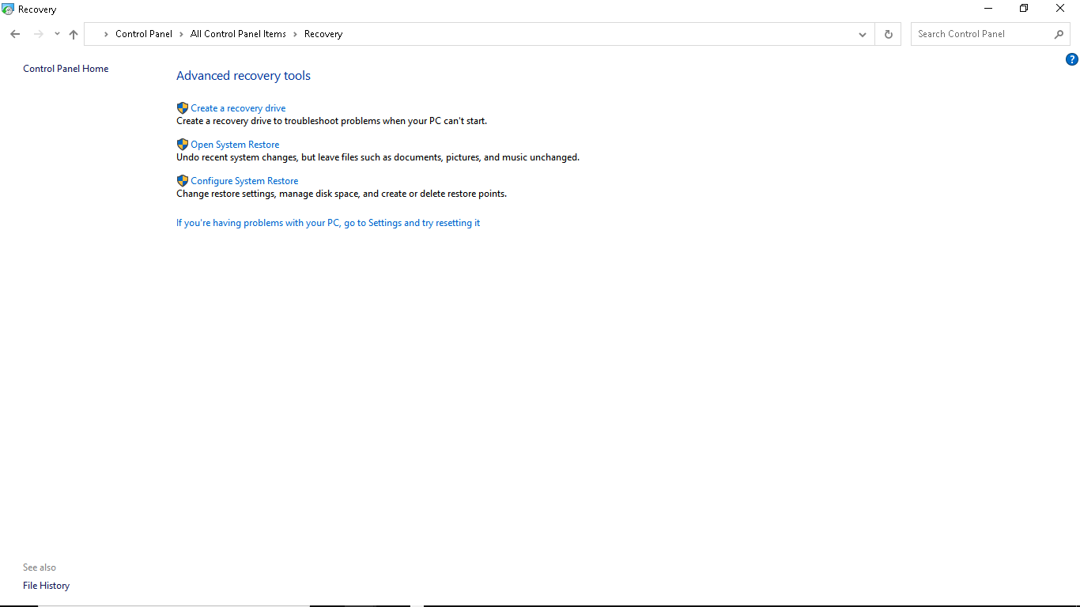

Problem 9
Keyboard not working
Step1: Open device manager
Step 2 : click on keyboard options
Step3: right click mouse and update driver

Screenshots:

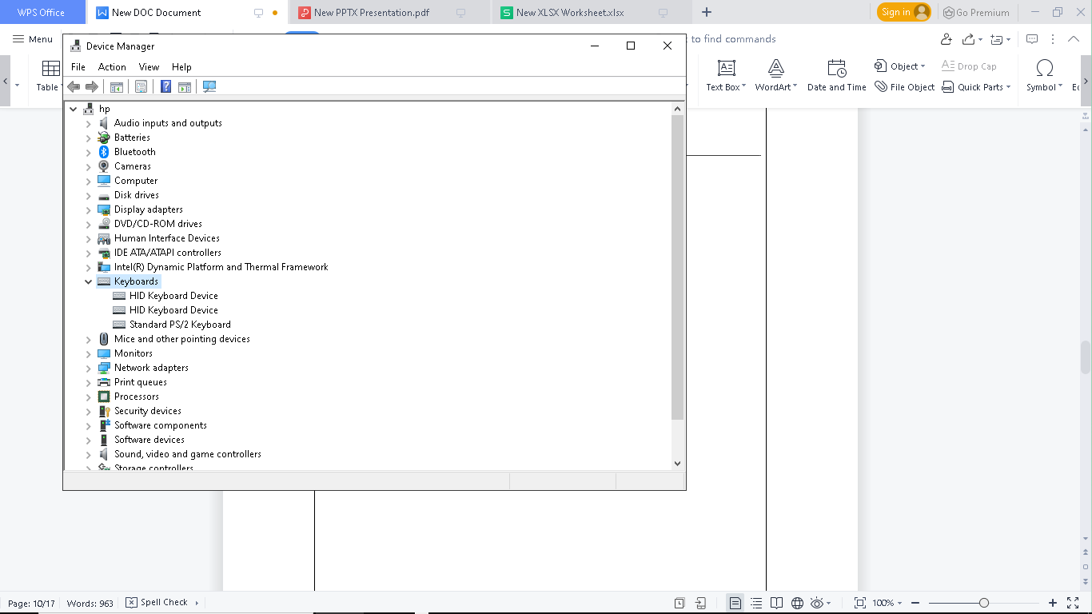

Another way

Step 1: windows +r =control Panel
Step2:Make sure view as catagory and click on access heading
Step3:click on change keyboard
Step 4 : make sure turn on filter keys checkbox is off

Screenshots:

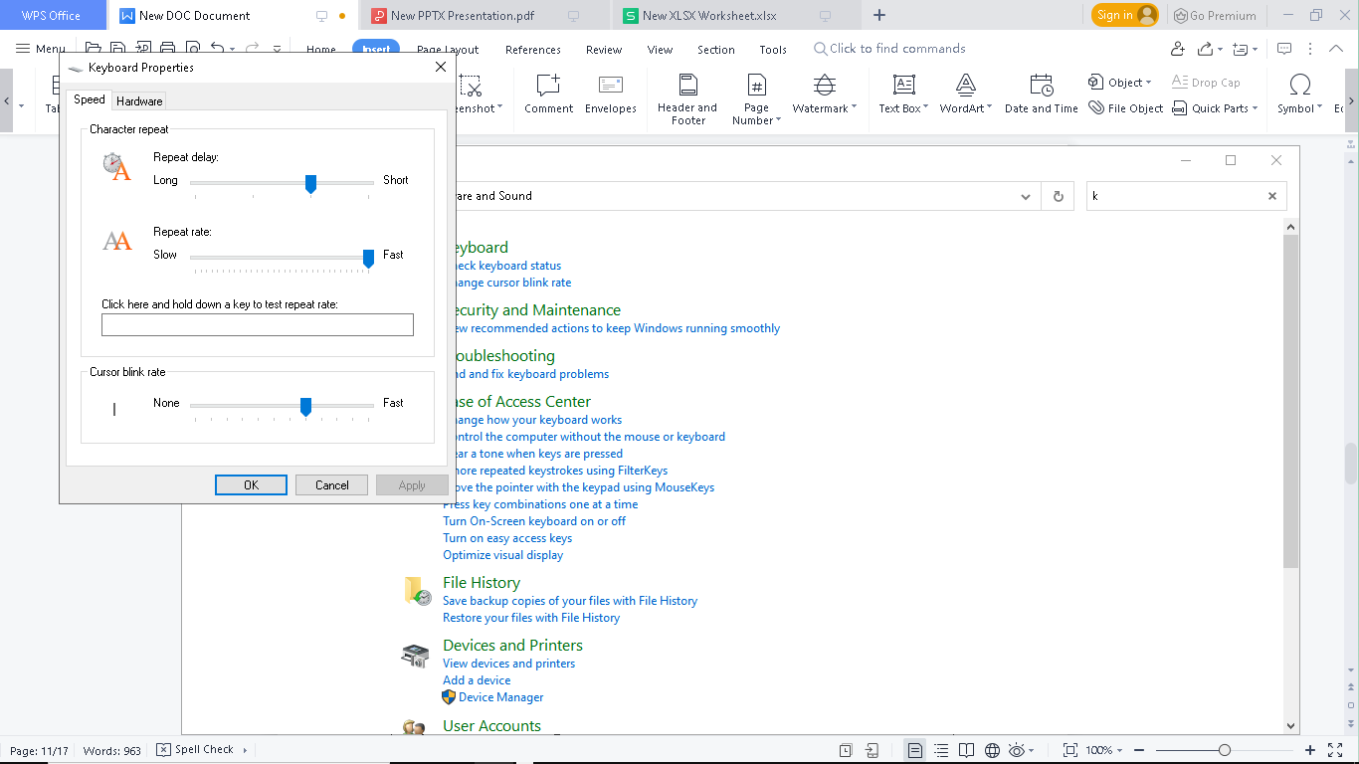

Problem 10
Programs is not responding

Step1: click on setting

Step2 :click on advanced system setting

Step3: Open performance and click setting

Step4: click on the advanced tab and under virtual memory

Step5:clear the automically manage paging file size for all drive checkbox

Screenshots:

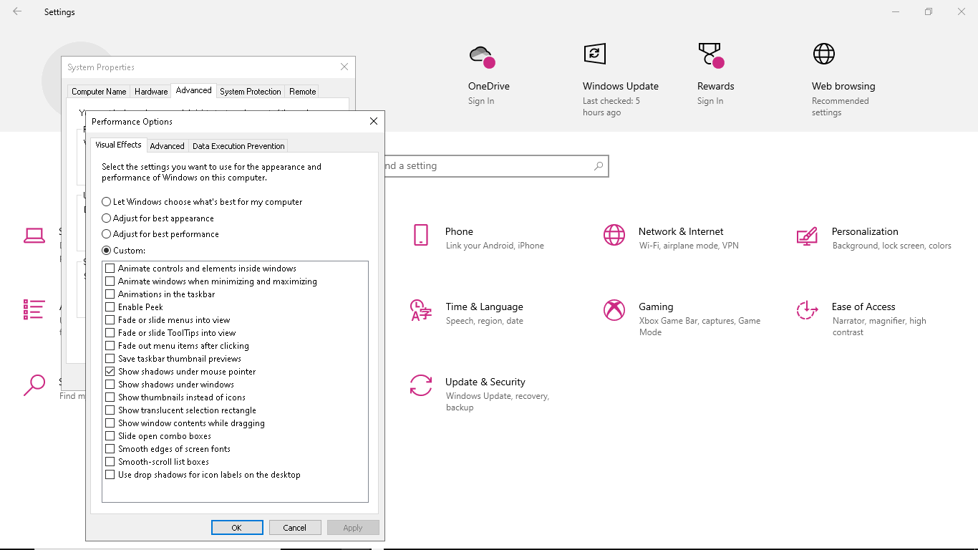

Problem 11

Microsoft Edge not working

Step1:go to the setting of microsoft edge

Step2: reset setting section reset edge to its originial

Screenshots:

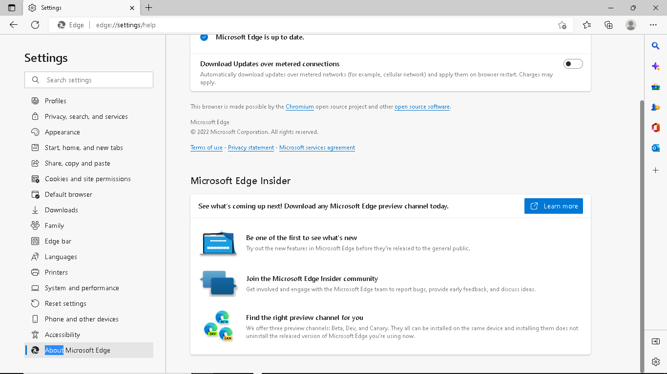

Problem 12

Start menu and taskbar not working

Step 1: go to desktop screen and make a new shortcut
Step2: type msconfig on the location

Step3: click give the short cut and name this

Step4 : next this shortcut name double click on this and click the boot tab on the top

Step5: click network underneath click apply

Step6: click on this apply

Screenshots:
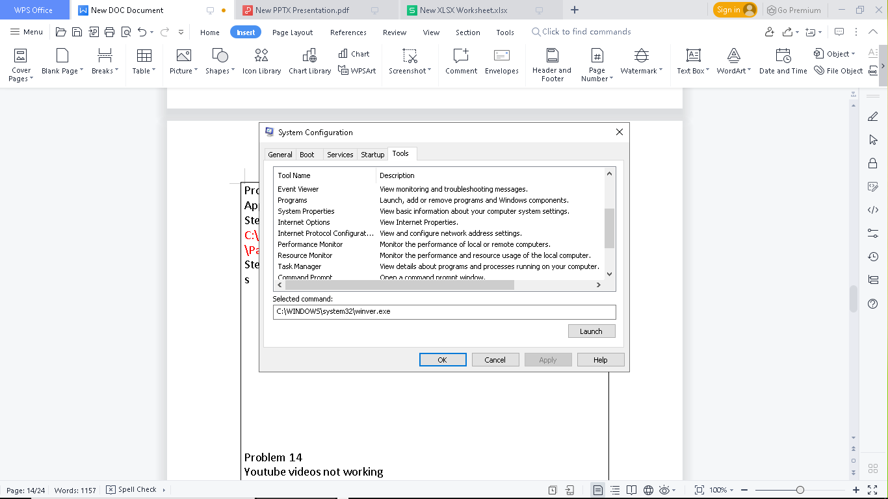

Problem 13
Appstore not working
Step1: Go to this location
C:\Users \user_ user name \App Data \Local \Packages/Microsoft .Windows Store _8wekyb3d8bbwe\Local Cache
Step2: this location delete all unnecessary file
s

Problem 14
Youtube videos not working
Step1: Go to the Internet Explorer and click on the internet option
Step2:open the advanced tab and make sure to check the box titled use rendering insteadof gpu
Step3: reendering right click on speakers and select different playback
Screenshots:
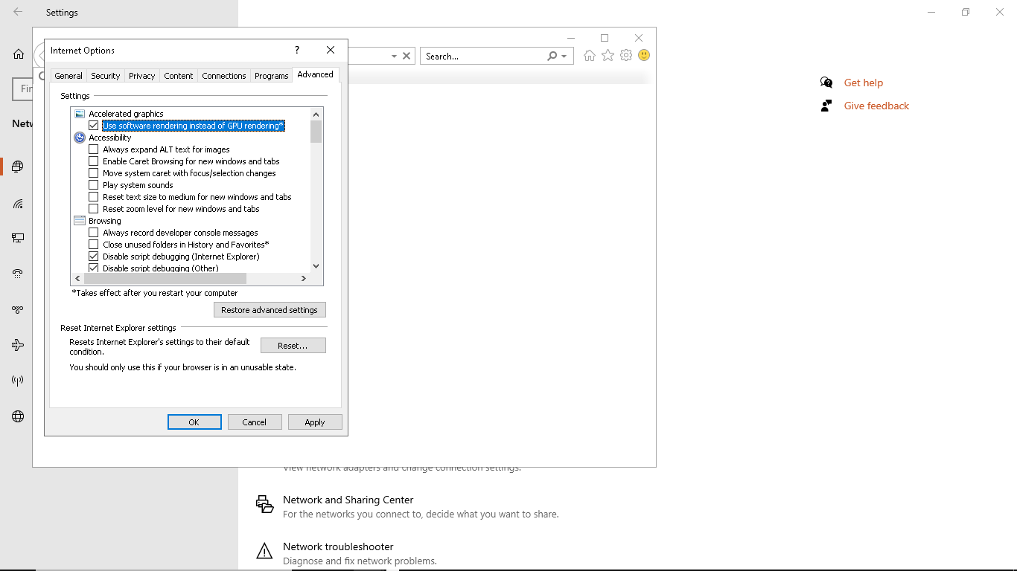
Problem 15
Unable to login microsoft account
Step1: windows +r =lusrmgr.msc
Step2: right click on the blank area and select new user option
Step3:enter the name of the user and choose a password
Step4 : uncheck the changing password and double click on this account
Screenshots
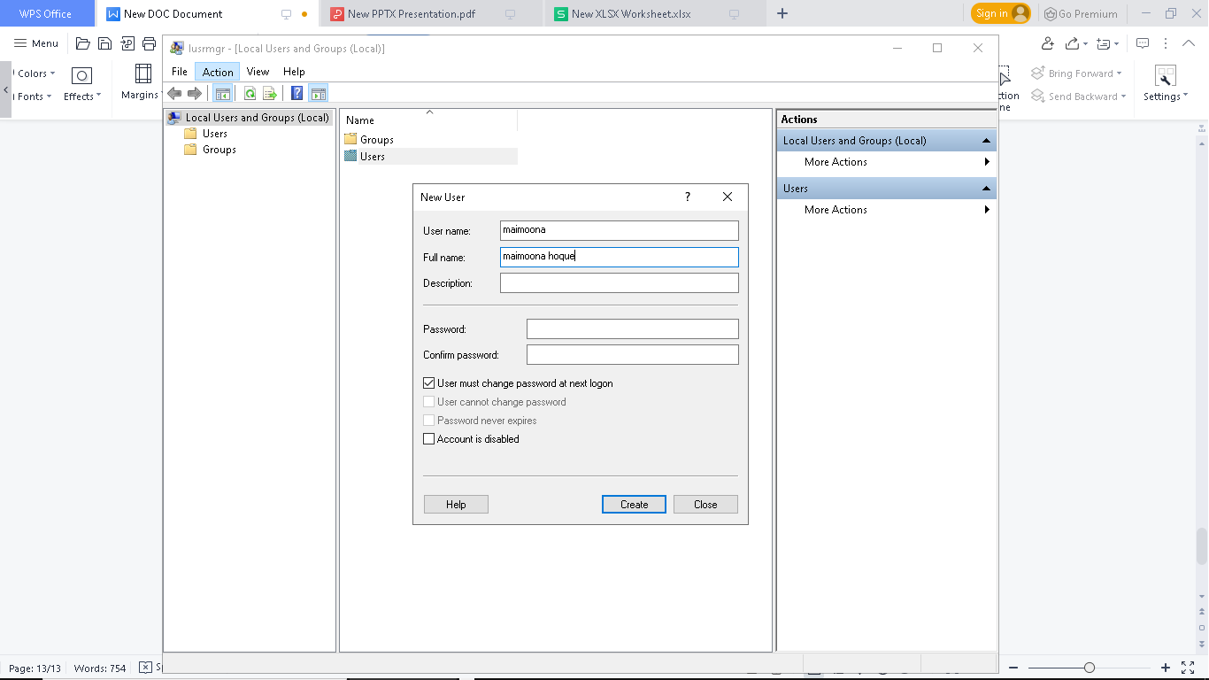
Problem, 16
Cannot seeNAS DRIVES in windows

Step 1 : In taskbar search CONTROL PROMPT

Step2: then type
Sc.exe config lanmanworkstation depend =bowser /mrxmb10/nsi
hit enter type
Sc .exe config mrxsmb20 start =disabled

Screenshots

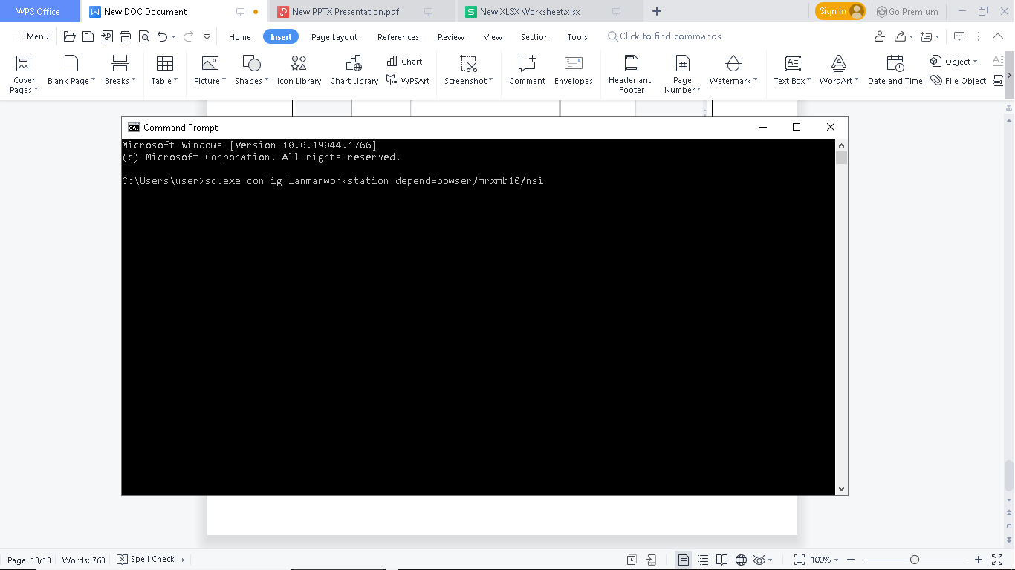

Problem18:

Unable to SHUT-DOWN or RESTART the computer

Step1: In taskbar search COMMAND PROMPT

Step2:type shutdown/s/t 0 and click enter

Screenshot

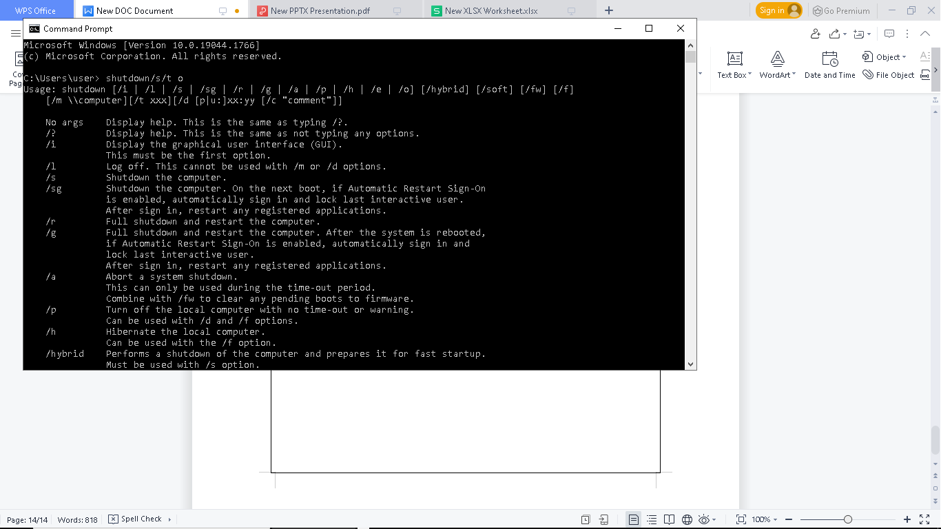

Problem 19:

Cannot Open Word Document

Step1: open control panel

Step 2: Select Microsoft word and hit change

Step3: choose the quick repair option

Screenshots:

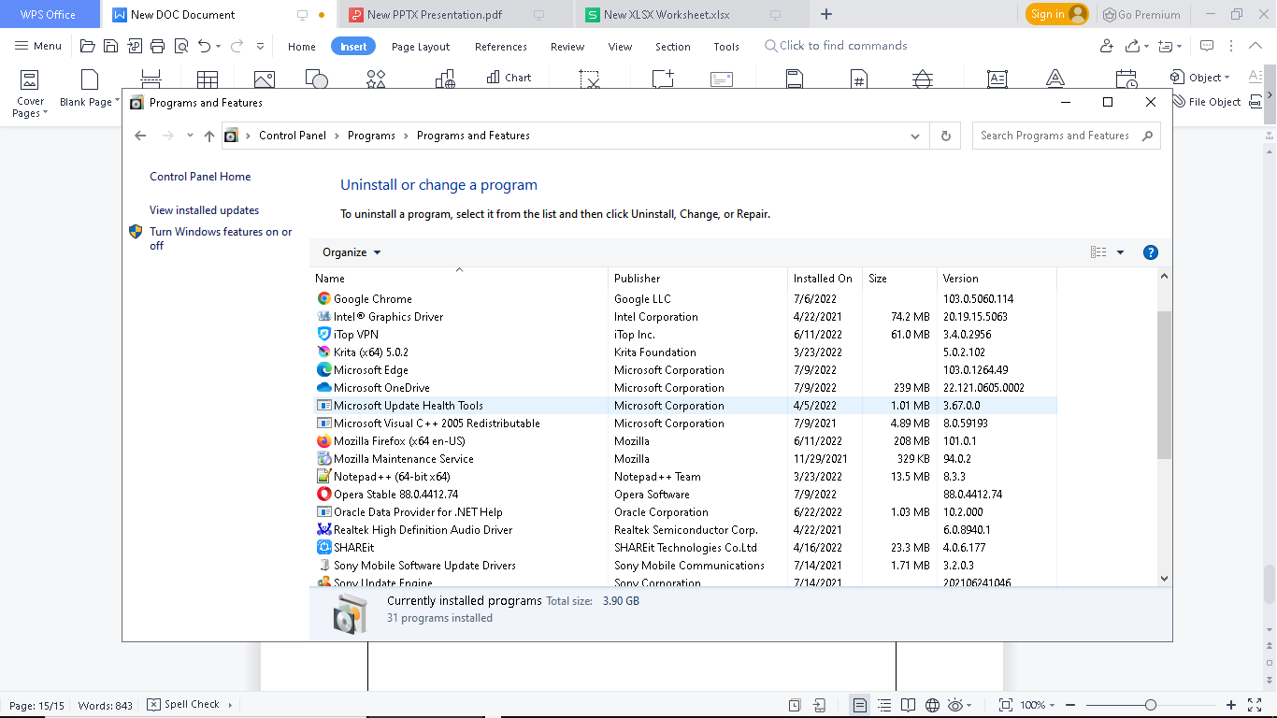

Problem20:

MIC not working

Step 1: open control panel

Step2: go to the Sound section

Step3: head over to the recording tab

Step 4 : check microphone is set as default double click on this

Step5: go to the properties level and make sure it is not muted

Screenshots :
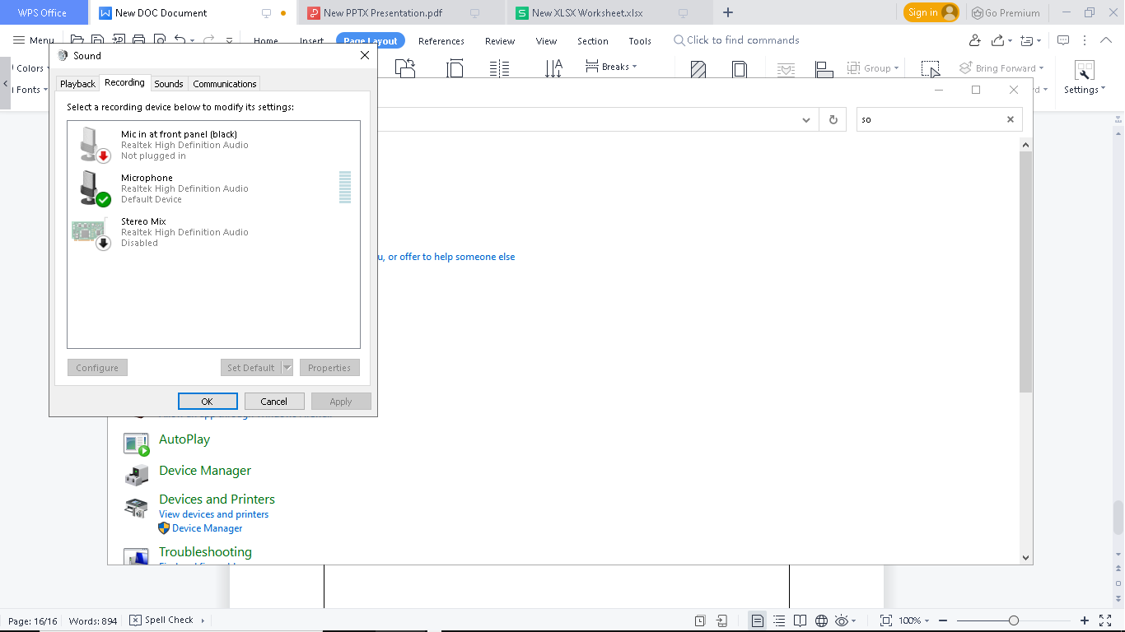
Problem21:

Internet not working

Step1: windows +r = regedit

Step2: open the Regestory Editor

Step3: go to the HKEY_LOCAL_MACHINE\SYSTEM\Current control set \Services\NIaSvc\Parameters\Internet

Step4: right click on enablev active probing and select modify
Screenshots:

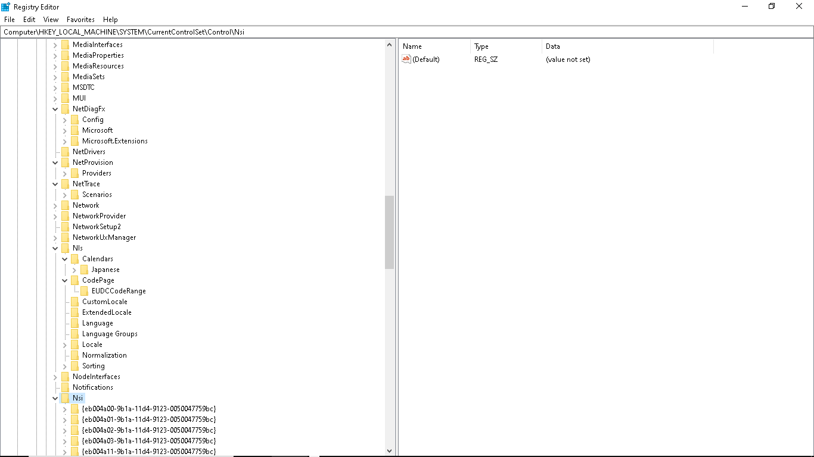

Problrm22:

Mouse not working

Tricks1:

Step1:Turn off my laptop and arrows keys to select power

Step2: use arrows keys to select shutdown

Screenshots:

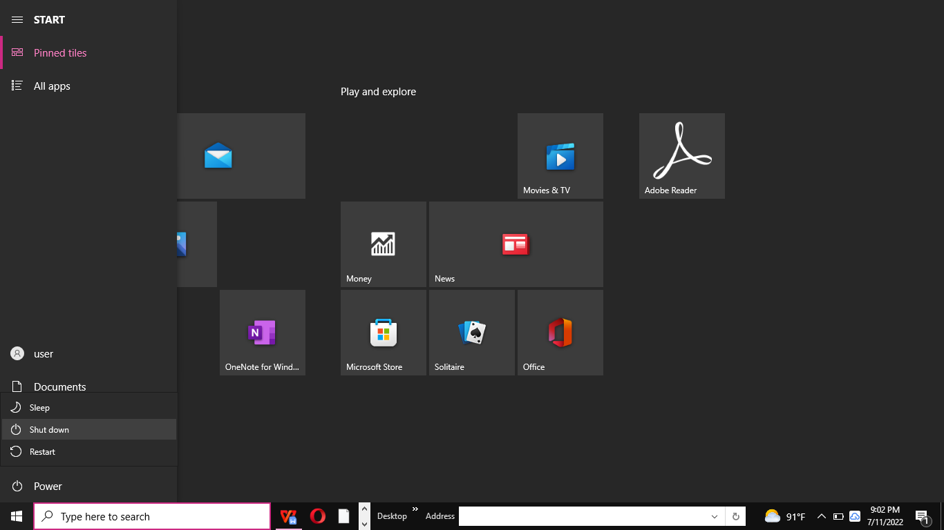

Tricks2:

Steps1:windows logo+r = devmgmt.msc

Step2:click Mice and other pointing device

Step3:click HD complaint mouse

Step4: open properties and click this device enable

Screenshots:

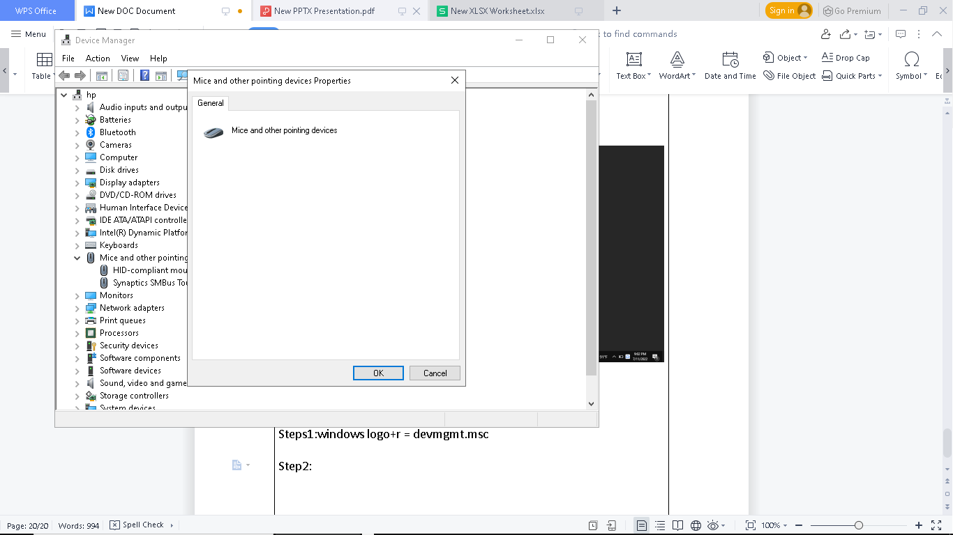

Problem23:

Touchpad not working

Step1:goto setting option

Step2: click on touchpad

Step3: make sure touchpad is on

Screenshots:

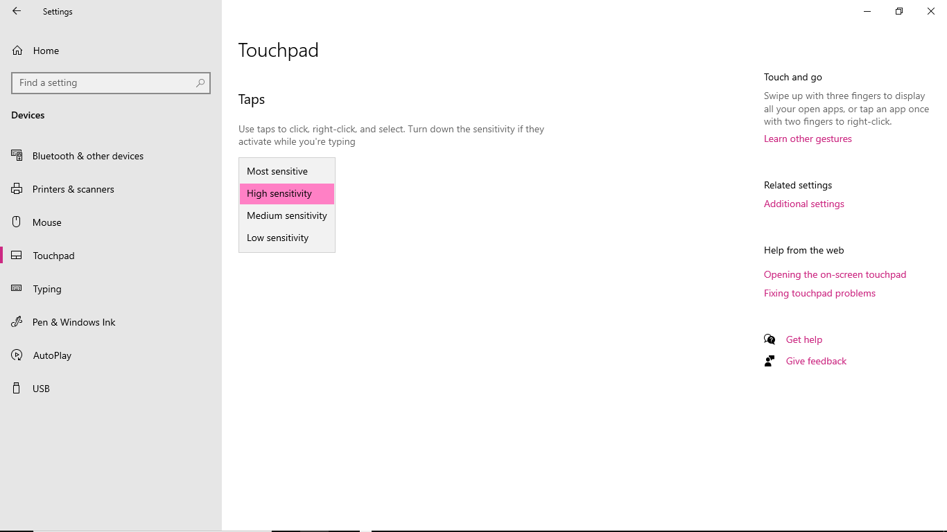
Problem24:

How to turn off windows Hidden /Background Downloads and Windows

Step1: My Computer to manage
Step3: services to windows update
- Services status to Stop
Step4: Windows Update
- Startup type to Disabled

Screenshots
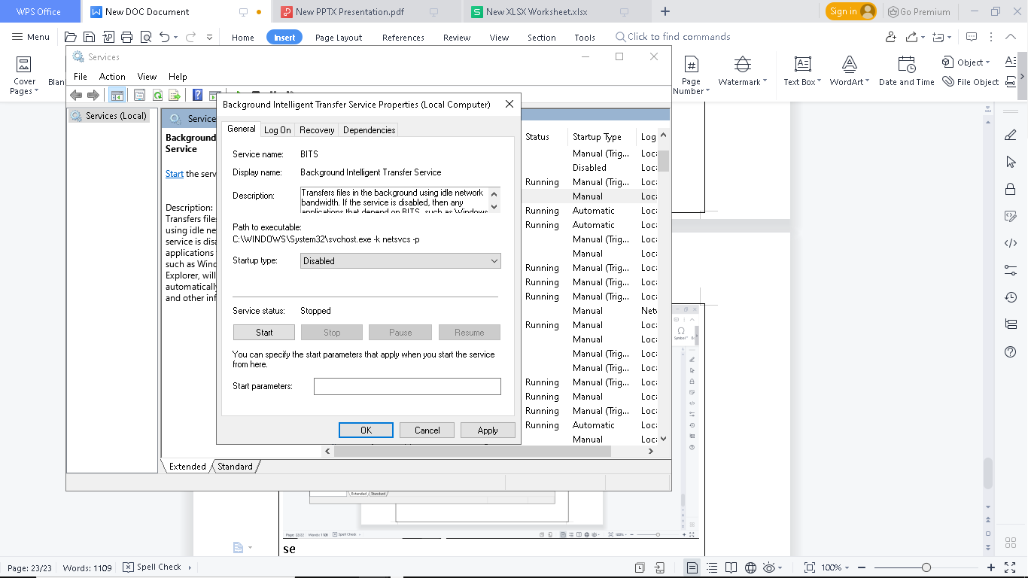

Turn off windows auto updated
Step1: windows +r =services.msc
Step2: select any appliacations and press w and scroll it down
Step3: look for windows update
Step4: Right click go to properties
Step 5 : select disabled
Screenshots:
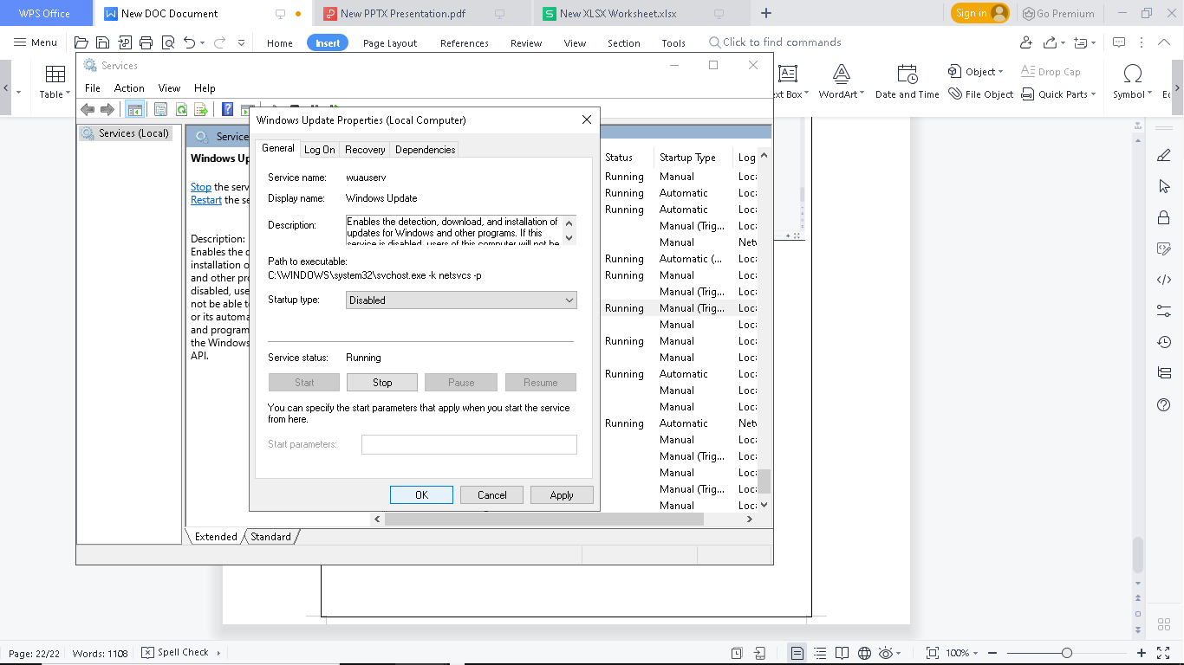
Tricks2:
Step1:windows+r=regedit
Step2: HKEY_LOCAL_MACHINE
Step3: select software \ polices\\microsoft\
Step4: looking for windows right click\new\
Step 5 : type au and hit enter
Screenshots:
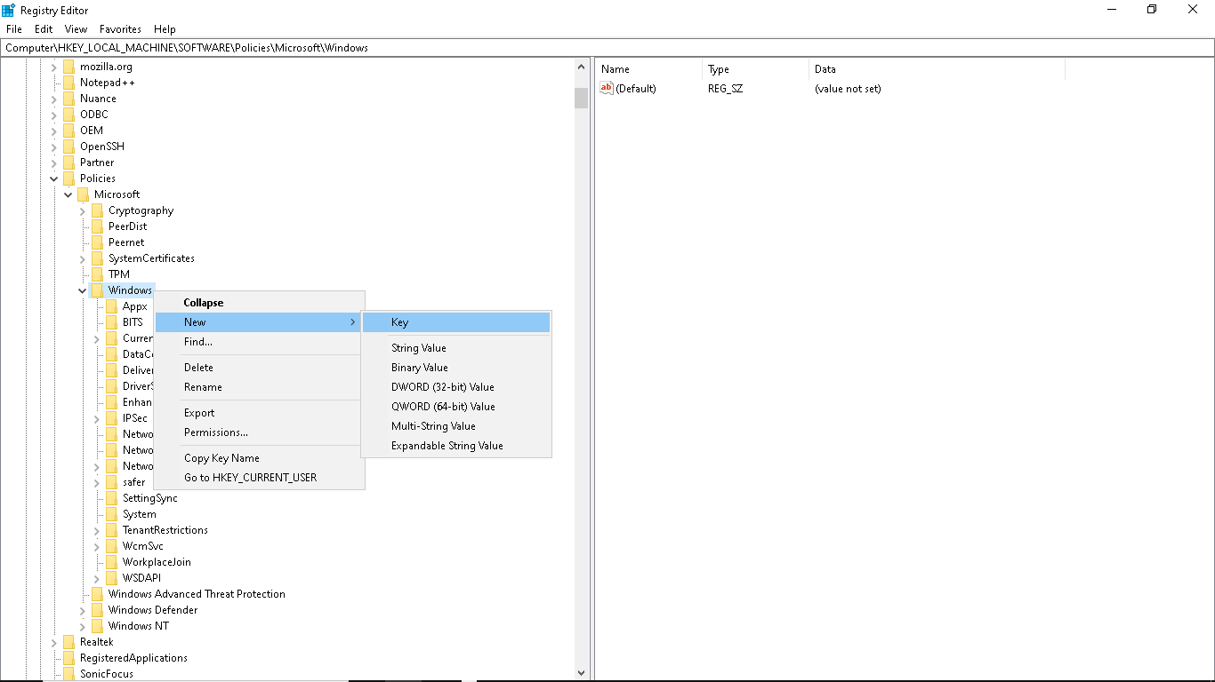

Problem 25:
Auto refresh my computer
Step1 : open text document
Step2: echo off
cd/
tree
c:
Tree
d:
tree
f:
tree
g:
Step3: saves name. Bat
Step4 : run
Screenshots:
Problem 27:
Hide personal files :
Step1: address bar to type cmd
Step 2: D(Folder name) :\> to attrib +h+s+r
Screenshots :
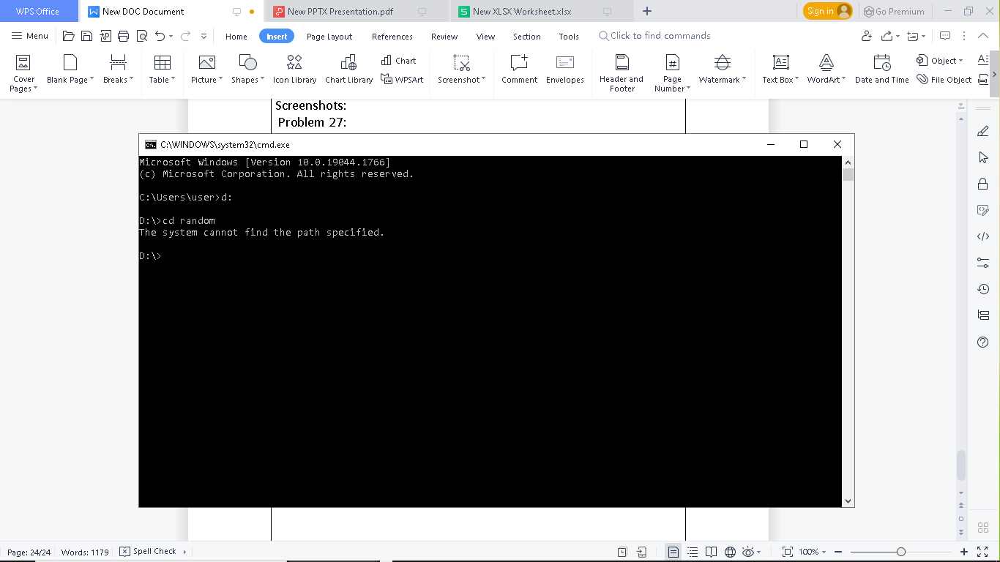
0pen:
Step1: address bar to cmd
Step2: D(folder name) ;\>to attrib -h- s - r ( type folder name)

Screenshots
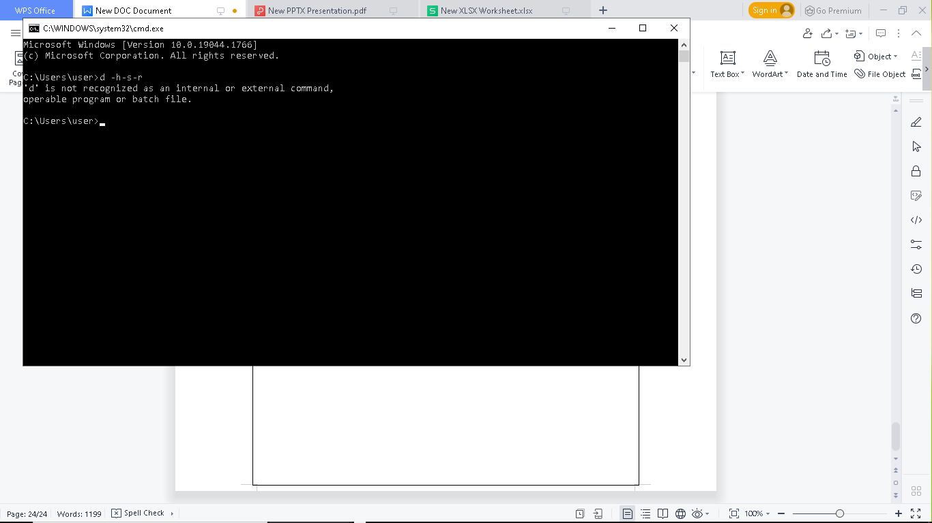

Problem28:

Lock files without software

Step1: open notepad

Step2 : pest code

Step3: save as .bat file

Step4: Doble click or run . bat file

Step5: enter all document in private file and open. Bat file

Screenshots :

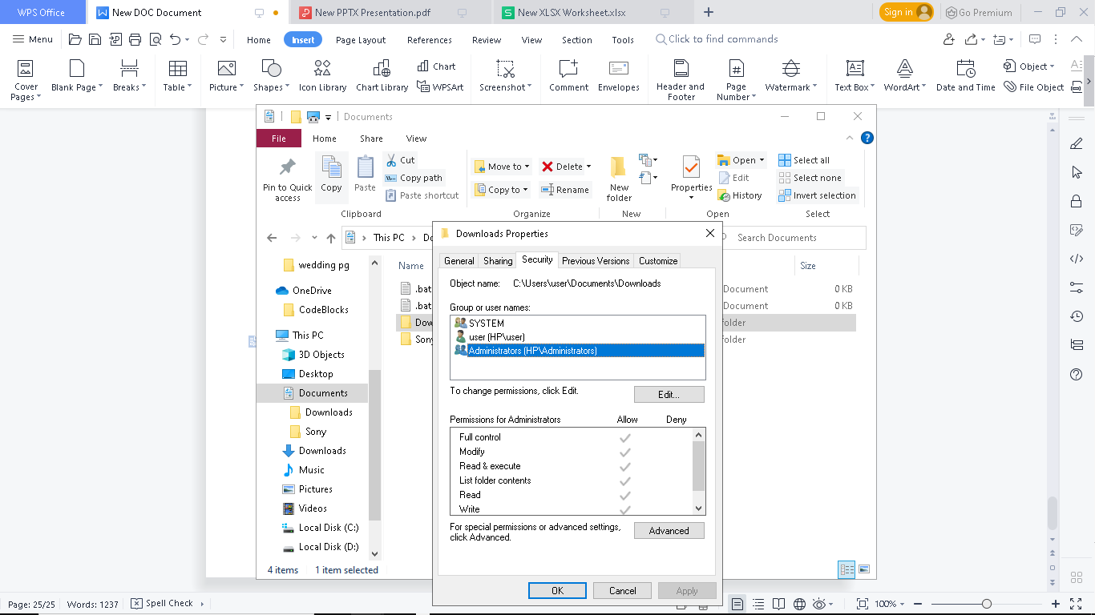
Unlock:

Open .bat file and type password

Problem29:

How to check computer missing drivers :

Step1: My Computer to Properties

Step2: properties to device manager

Step3: device manager to scan for hardware changes

Screenshots :

